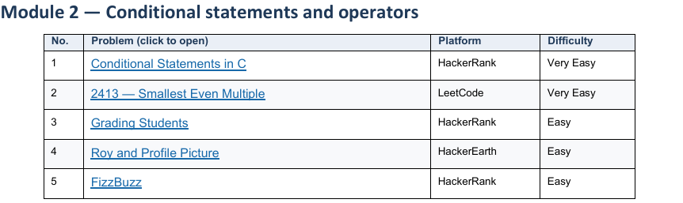
1 Conditional Statements in C HackerRank
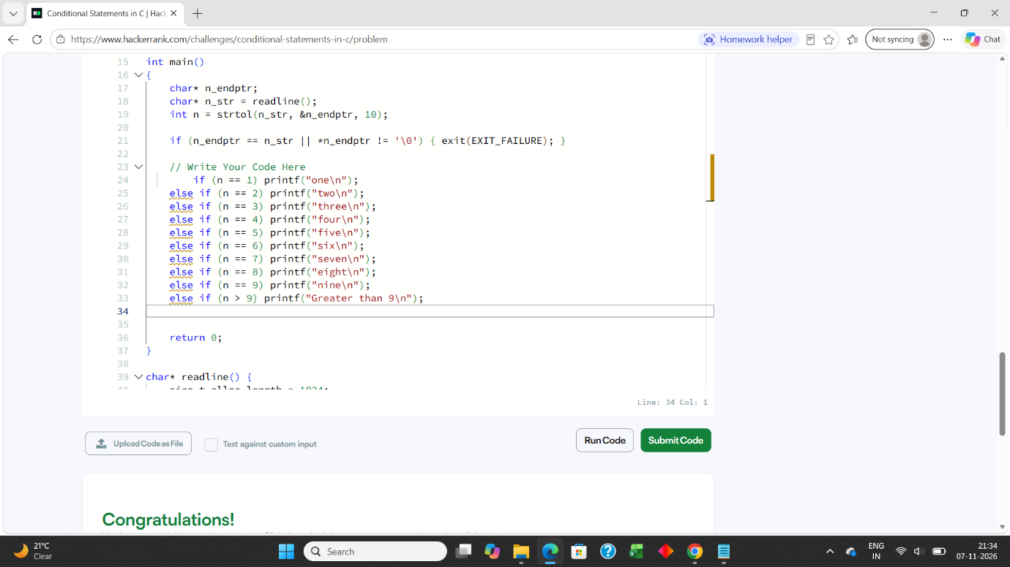

2 2413 — Smallest Even Multiple LeetCode

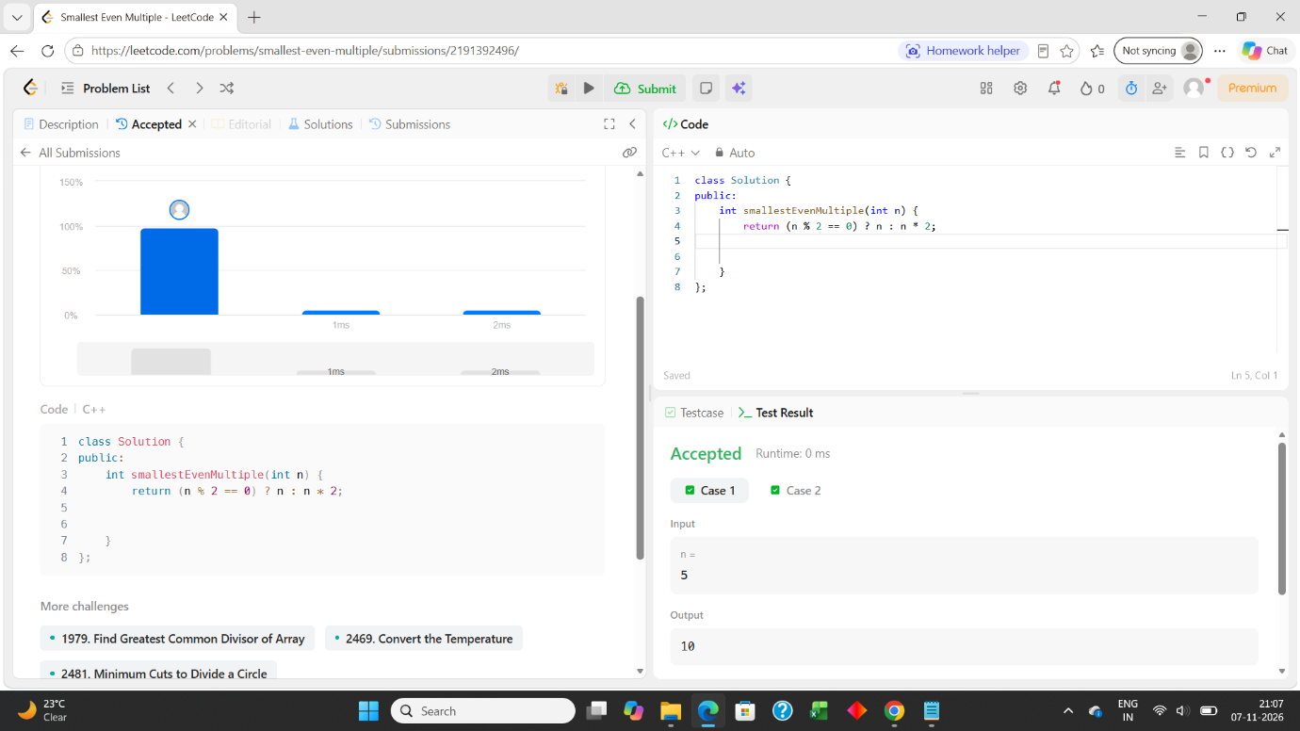

3 Grading Students HackerRank
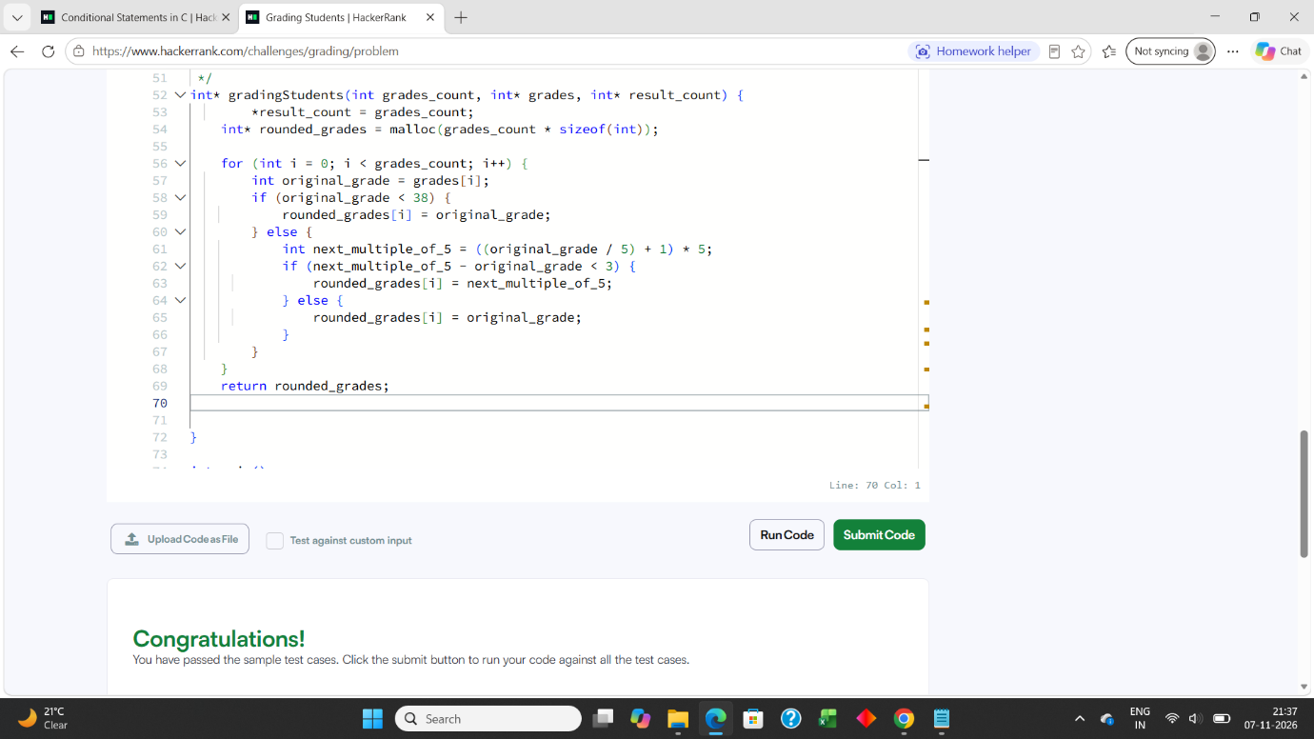

4 Roy and Profile Picture HackerEarth
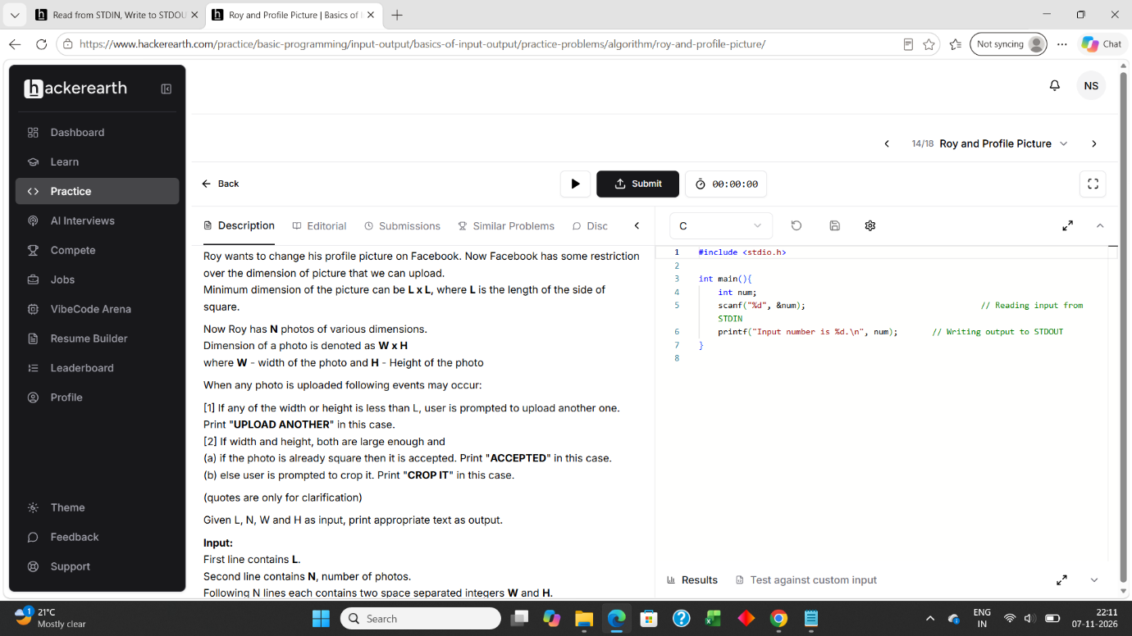

5 FizzBuzz HackerRank


